

PROJECT REPORT

Prepared by:
Aruana Sadubayeva,Kenessary Garifulla,Arlan Toktarkhan
Information systems in business
Submitted to:
Alisher Aldashev

Almaty, 2024-2025

EXECUTIVE SUMMARY

TABLE OF CONTENTS
1.INTRODUCTION 4
2.KEY INSIGHTS FROM THE DASHBOARDS 5
2.1 MARKET ANALYSIS DASHBOARD 5
2.2 LOGISTICS PERFORMANCE ANALYSIS 6
2.3 GENERAL OVERVIEW DASHBOARD 7
2.4 GEOGRAPHIC ANALYSIS DASHBOARD 8
2.5 CATEGORY PROFIT ANALYSIS DASHBOARD 10
3.RECOMMENDATIONS FOR SENIOR MANAGEMENT 11
4.CONCLUSION 12

1.INTRODUCTION

2.KEY INSIGHTS FROM THE DASHBOARDS

2.1 MARKET ANALYSIS DASHBOARD
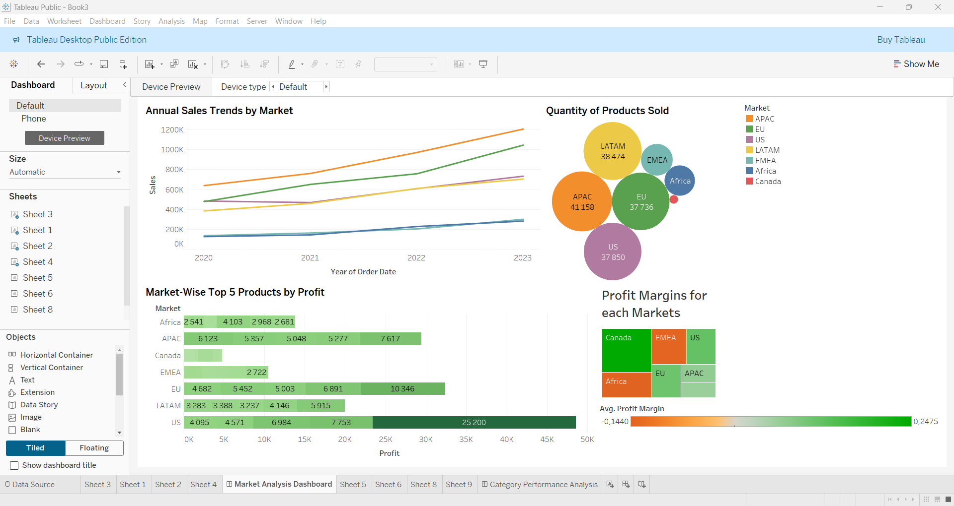

The dashboard depicts the world contribution in sales by distinct markets and the profit amount of those markets during the period from 2020 to 2023.
In the annual sales each market showed an upward trend. The leading position of growth rate and overall sales is held by APAC, with steady increases each year, exceeding 1.2 million sales in 2023. While APAC dominates sales contributions, the US stands out in profitability, suggesting that the US excels in operational efficiency and high-margin product performance. It is proven by the US’s top 5 product profitability, generating almost 50000 dollars, which is more than twice as high as for Latin America (LATAM). Thus, while APAC dominates sales and product quantities, the US leads in profitability due to its focus on high-value items. LATAM sold a high number of products (over 38,000 units), but its profitability is moderate compared to APAC or the US. Regarding EMEA and the market of Africa, they both had not only a slow growth rate in sales, but also negative average profit margins. The Canada market performed the worst in sales, although had the greatest profit margin among all markets.

2.2 LOGISTICS PERFORMANCE ANALYSIS
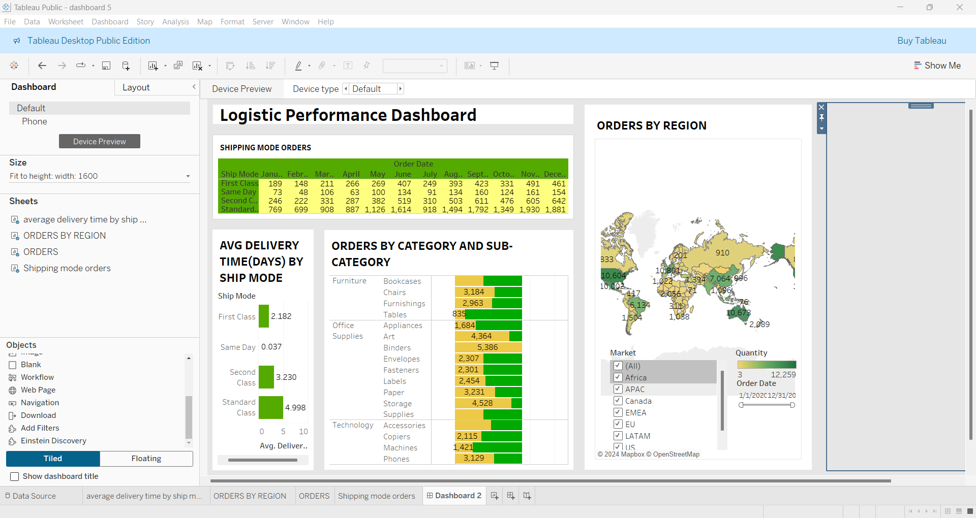
The Logistics Performance Dashboard provides key information on transportation methods, product requirements and regional indicators, highlighting areas for optimization.
Shipping mode orders and average delivery time(days) by ship mode
From the table,it can be seen that standard shipments significantly exceeded first class (461 orders) and same day (154 orders), reaching a maximum of 1,930 orders per month, which accounts for the majority of orders. However, compared to first class (3.230 days) and second class (3.230 days), the average delivery time for standard shipping is 4.998 days. Same day shipping is the fastest, taking an average of only 0.037 days, but is used less frequently. Improving the efficiency of standard shipping can significantly improve customer satisfaction and operational efficiency.
Orders by category and subcategory
The dashboard shows that binders lead office supplies (5,386 orders), while furniture tables lagged behind (835 orders). Mobile phones performed well (3,129 cases), while machines lagged behind (1,421 cases). Focusing on demanding items like binders and eliminating weak points like tables can help to achieve the best results.
Orders by region
The United States leads with 10,604 orders, followed by Australia (10,673 orders). Canada has 833 orders, but only 1,508 are delayed in Latin America, such as Brazil. In EMEA as a whole, Western Europe (e.g. Germany's 7,064 orders) surpassed Eastern Europe (910 orders). Strategic goals for Latin America and Asia Pacific may provide growth opportunities.
Conclusion
The analysis shows that optimizing standardized deliveries and integrated services for high-demand category such as office supplies can significantly improve logistics efficiency and customer satisfaction. The company should primarily address the problem of lower delivery times and uneven performance across regions.

2.3 GENERAL OVERVIEW DASHBOARD
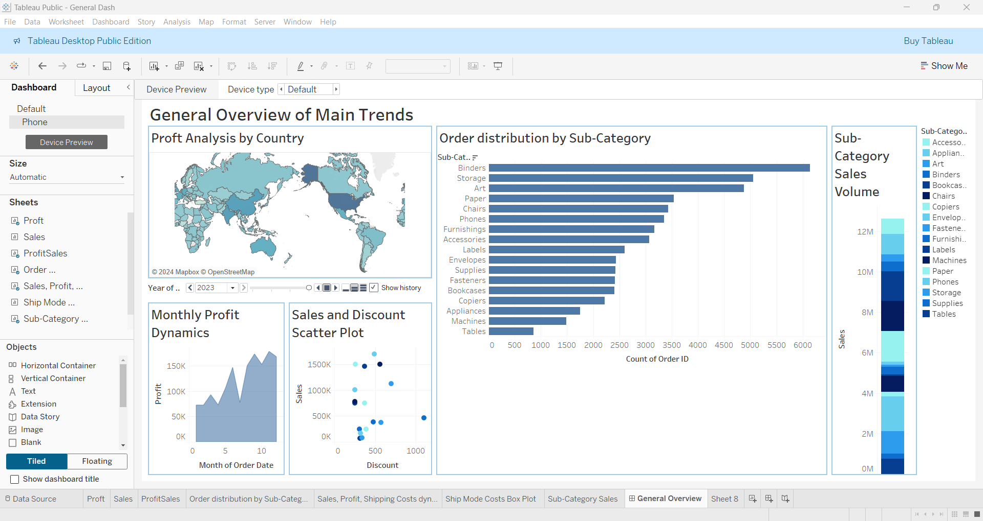
The dashboard holds an analysis of profit, discount and sales from the sub-categories to the country levels.
The map, "Profit Analysis by Country" demonstrates the most profitable countries starting from 2020 till 2023. We can see that the USA, Mexico, China, Australia, India and some West European countries are maintaining their leadership throughout the period as the highest profit-attracted countries.
The chart "Order Distribution by Sub-Category" concludes that Binders and Storage are most ordered sub-categories, although they are not leading in terms of sales volume, compared to other sub-categories, like Bookcases, Phones, Copiers. While other sub-categories like Machines and Tables have got less demand and sales respectively.
The scatter plot for "Profit and Discount" shows a weak negative correlation between discount and profit. Generally, the increase in discount decreases profit, hence it needs a better pricing strategy depending on the product. The exception is in the sub-category Tables, which shows a clashing trend to what is mostly observed.
On the basis of the graph, "Dynamics of Profit per Month", the profits are also seasonal, peaking in June, September, November, and December. Early in the year and mid-summer resulted in the greatest few profits.

2.4 GEOGRAPHIC ANALYSIS DASHBOARD
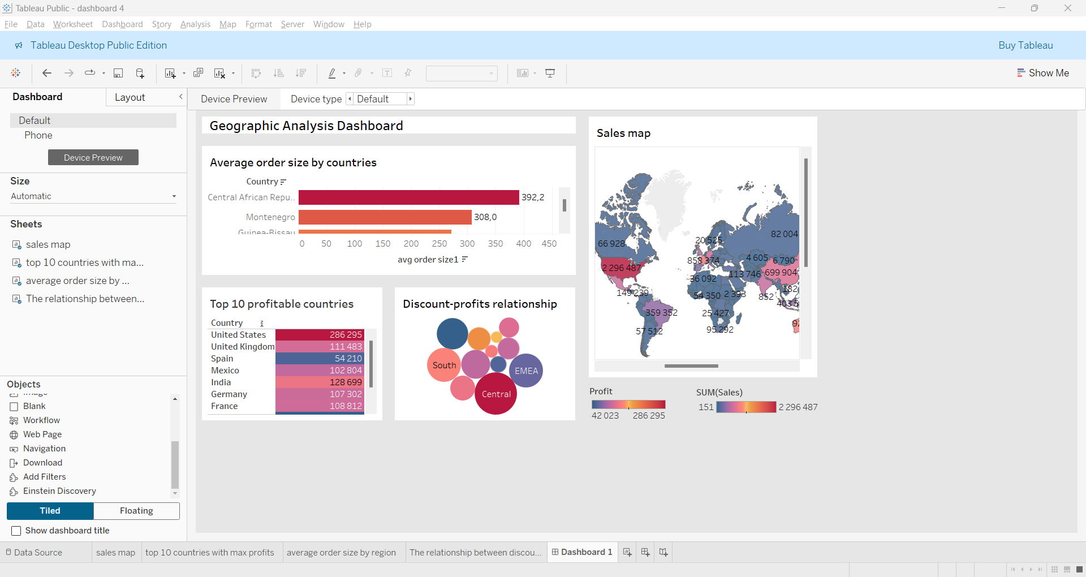
The given geographic analysis dashboard displays important information about regional sales, profitability, and the relationship between discounts and profits.
Top 10 profitable countries
The United States leads with the largest increase ($286,295), followed by China ($150,535) and India ($1,128,699). El Salvador has the lowest profit of the 10 countries ($42,023), indicating potential for improvement.
Average Order Size
Uruguay leads in average order volume (658.3), followed by Montenegro (6,604.7) and Slovenia (1,027.7). Countries such as China ($363.3) and India ($3,369.2) indicate significantly lower order volumes. Uruguay's success should be replicated and attention should be focused on encouraging bulk purchasing in underperforming regions.
Discount-Profits relationship
The bubble chart shows profit-discount relationships by region. The Central region leads with the highest profit (311,048), followed by North (194,166) and South (139,822). Africa uses high discounts but yields lower profits, while Southeast Asia shows minimal discounts and profits. Balanced discount strategies drive success in high-performing regions
Sales Distribution
The sales map shows the distribution of sales worldwide. The United States leads with 2,296,487 sales, followed by Canada (66,926) and Europe (82,004). Sales in Asia and Australia are moderate (52,928,42,453), while sales in Africa and South America are low (28,546,35,042), indicating potential growth opportunities in these regions.
Conclusion
The findings suggest that there is a focus on optimizing discounts in underperforming regions, driving marketing in low-income countries, and leveraging the strong performance of the US market for sustainable growth.

2.5 CATEGORY PROFIT ANALYSIS DASHBOARD
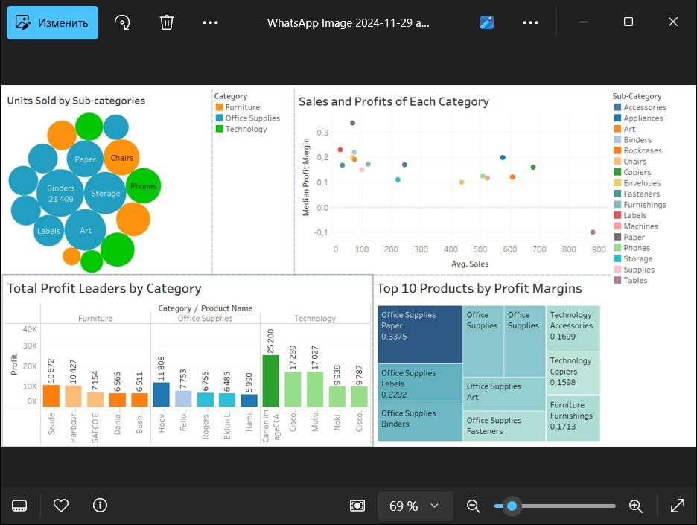
The dashboard provides a comprehensive view of sales and profitability across categories and sub-categories, highlighting the interconnections between sales volume, profit generation, and margin efficiency.
To begin, Office Supplies dominate sales quantities, however, it can be seen from “Total Profit Leaders by Category” chart that sales volume does not always correlate with high profitability. For instance, while Binders excel in units sold (over 21000 units), Technology sub-categories like Phones achieve far greater profits, thus demonstrating that profitability is not solely dependent on volume. As for The “Top 10 Products by Profit Margins” treemap, it also emphasizes the contribution of Office Supplies as the most efficient category. Products like Paper and Labels achieve the highest profit margins (0.3375 and 0.2292, respectively), despite moderate sales. In contrast, Furniture sub-categories such as Chairs, appear in the sales chart but lag in profitability and margin rankings. There are profitability and reasonable margins in technological products like Copiers and Phones, which takes the leadership in total profits (e.g. 25200 dollars for ‘Cisco imageCLASS 2200’). The “Sales and Profits by Each Category” scatter plot ties these insights together by showing the trade-off between average sales and profit margins. Office Supplies achieve high margins but moderate sales, Technology balances sales and margins, and Furniture emphasizes sales volume with lower margins.

3.RECOMMENDATIONS FOR SENIOR MANAGEMENT

4.CONCLUSION

